1. a. Differentiate between cardinality and degree of a table with the help of an example.2
Ans : Cardinality is defined as the number of rows in a table.
Degree is the number of columns in a table.

Eg:Consider the following tables:

Table : Account

Acno | Cname
Ac100 | Sheela
Ac101 | Darsh
Ac102 | Kathy

Cardinality of Account table is : 3 Degree of Account table is :2
- Consider the following tables FACULTY and COURSES. Write SQL commands for the statements (i) to (v) and give outputs for SQL queries (vi) to (vii) 6

FACULTY
F_ID | Fname | Lname | Hire_date | Salary
102 | Amit | Mishra | 12-10-1998 | 12000
103 | Nitin | Vyas | 24-12-1994 | 8000
104 | Rakshit | Soni | 18-5-2001 | 14000
105 | Rashmi | Malhotra | 11-9-2004 | 11000
106 | Sulekha | Srivastava | 5-6-2006 | 10000
COURSES
C_ID | F_ID | Cname | Fees
C21 | 102 | Grid Computing | 40000
C22 | 106 | System Design | 16000
C23 | 104 | Computer Security | 8000
C24 | 106 | Human Biology | 15000
C25 | 102 | Computer Network | 20000
C26 | 105 | Visual Basic | 6000
  - To display details of those Faculties whose salary is greater than 12000.
Ans: Select * from faculty where salary > 12000

  - To display the details of courses whose fees is in the range of 15000 to 50000 (both values included).
Ans: Select * from Courses
.where fees between 15000 and 50000

  - To increase the fees of all courses by 500 of “System Design” Course.
Ans: Update courses set fees = fees + 500 where Cname = “System Design”

  - To display details of those courses which are taught by ‘Sulekha’ in descending order of courses.
Ans: Select * from faculty fac,courses cour where fac.f_id = cour.f_id
and fac.fname = 'Sulekha' order by cname desc

  - Select COUNT(DISTINCT F_ID) from COURSES;
Ans: 4

  - Select MIN(Salary) from FACULTY,COURSES where COURSES.F_ID = FACULTY.F_ID;
Ans: 8000

2. | Consider the following DEPT and EMPLOYEE tables. Write SQL queries for (i) to (iv) and find outputs for SQL queries (v) to (viii).  Table: DEPT

DCODE | DEPARTMENT | LOCATION
D01 | INFRASTRUCTURE | DELHI
D02 | MARKETING | DELHI
D03 | MEDIA | MUMBAI
D05 | FINANCE | KOLKATA
D04 | HUMAN RESOURCE | MUMBAI

Table: EMPLOYEE
ENO | NAME | DOJ | DOB | GENDER | DCODE
1001 | George K | 2013­09­02 | 1991­09­01 | MALE | D01
1002 | Ryma Sen | 2012­12­11 | 1990­12­15 | FEMALE | D03
1003 | Mohitesh | 2013­02­03 | 1987­09­04 | MALE | D05
1007 | Anil Jha | 2014­01­17 | 1984­10­19 | MALE | D04
1004 | Manila Sahai | 2012­12­09 | 1986­11­14 | FEMALE | D01
1005 | R SAHAY | 2013­11­18 | 1987­03­31 | MALE | D02
1006 | Jaya Priya | 2014­06­09 | 1985­06­23 | FEMALE | D05

Note: DOJ refers to date of joining and DOB refers to date of Birth of employees.
 | (i) To display Eno, Name, Gender from the table EMPLOYEE in ascending order of Eno.
Ans | SELECT Eno,Name,Gender FROM Employee ORDER BY Eno asc;
 | (ii) To display the Name of all the MALE employees from the table EMPLOYEE.
Ans | SELECT Name FROM Employee WHERE Gender=’MALE’;
 | (iii) To display the Eno and Name of those employees from the table EMPLOYEE who are born between '1987‐01‐01' and '1991‐12‐01'.
Ans | SELECT Eno,Name FROM Employee  WHERE DOB BETWEEN ‘1987­01­01’ AND ‘1991­12­01’  OR  SELECT Eno,Name FROM Employee  WHERE DOB >=‘1987­01­01’ AND DOB <=‘1991­12­01’;  OR  SELECT Eno,Name FROM Employee  WHERE DOB >‘1987­01­01’ AND DOB <‘1991­12­01’;

 | WHERE DOB BETWEEN ‘1987­01­01’ AND ‘1991­12­01’ OR WHERE DOB >=‘1987­01­01’ AND DOB <=‘1991­12­01’ OR WHERE DOB >‘1987­01­01’ AND DOB <‘1991­12­01’ )
 | (iv) To count and display FEMALE employees who have joined after '1986‐01‐01'.
Ans | SELECT count(*) FROM Employee  WHERE GENDER=’FEMALE’ AND DOJ > ‘1986­01­01’;  OR  SELECT * FROM Employee  WHERE GENDER=’FEMALE’ AND DOJ > ‘1986­01­01’;  (Any valid query for counting and/or displaying for female employees will be awarded 1 mark)
 | (v) SELECT COUNT(*),DCODE FROM EMPLOYEE GROUP BY DCODE HAVING COUNT(*)>1;
Ans | COUNT DCODE  2 D01  2 D05
 | (vi) SELECT DISTINCT DEPARTMENT FROM DEPT;
Ans | Department INFRASTRUCTURE MARKETING MEDIA  FINANCE  HUMAN RESOURCE
 | (vii) SELECT NAME, DEPARTMENT FROM EMPLOYEE E, DEPT D WHERE E.DCODE=D.DCODE AND EN0<1003;
Ans | NAME DEPARTMENT  George K INFRASTRUCTURE  Ryma Sen MEDIA
 | (viii) SELECT MAX(DOJ), MIN(DOB) FROM EMPLOYEE;
Ans | MAX(DOJ) MIN(DOB)  2014­06­09 1984­10­19
Write SQL quries to perform the following based on the table PRODUCT having fields as below.Write SQL command for (1) to(4) Each carries 2 marks(4x2=8)

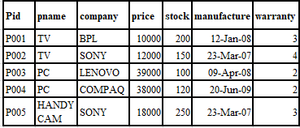
Product Table
  - To list the company which gives warranty for more than 2 years?
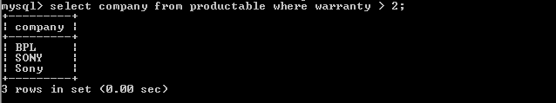
  - To find stock value of the BPL Company where stock value is sum of the product of price and stock.
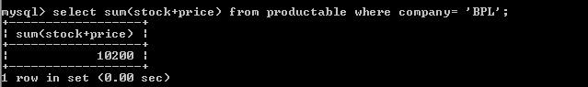
  - To show number of products from each company.
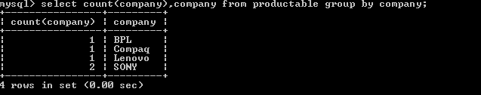
  - To count the number of products for which manufacture falls between ‘2008-01-01’ to ‘2009-12-31’.
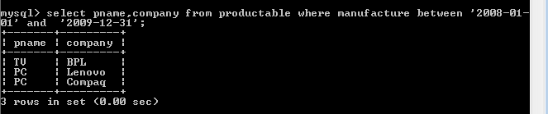

Write the SQL queries for the following based on EMPLOYEES and EMPSALARY table. Each carries 2 marks(4x2=8)

EMPLOYEES
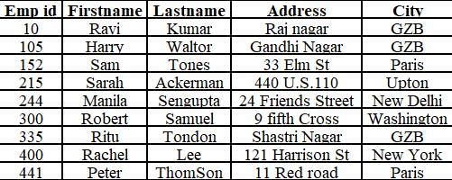
EMPSALARY
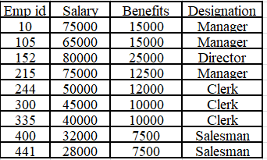
- To show firstname, lastname, address and city of all employee living in Paris.
SELECT firstname, lastname, address from employee where city=”paris”;
- To Display the content of Employees table in descending order of firstname.
Select firstname from employee order by firstname desc;

Give the Output Of the following SQL Commands:
- Select firstname, salary from employees, empsalary where designation =”salesman “and employee .empid=Empsalary.empid;
Rachel | 32000
Peter | 28000

- Select designation, sum (salary) from empsalary group by designation having count (*)>2;
Manager | 215000
Clerk | 135000

